Anaconda installation

1. Open Bash

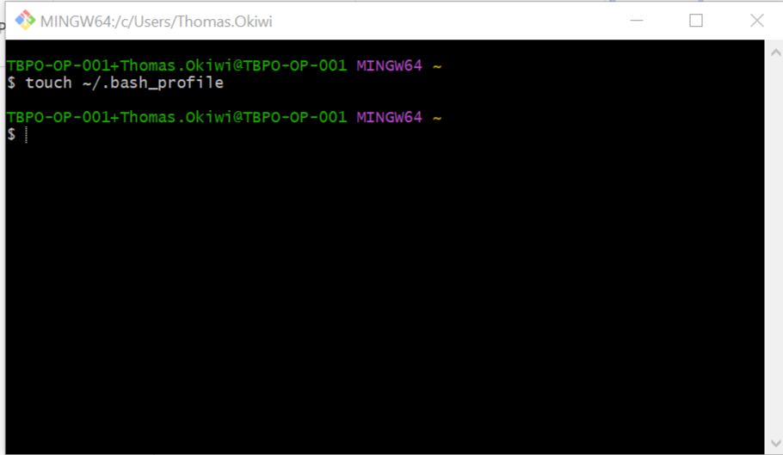

Type touch---- as show, press enter to run the command

1. Close the Bash terminal.
2. Go to windows explorer, Open the anaconda path as shown

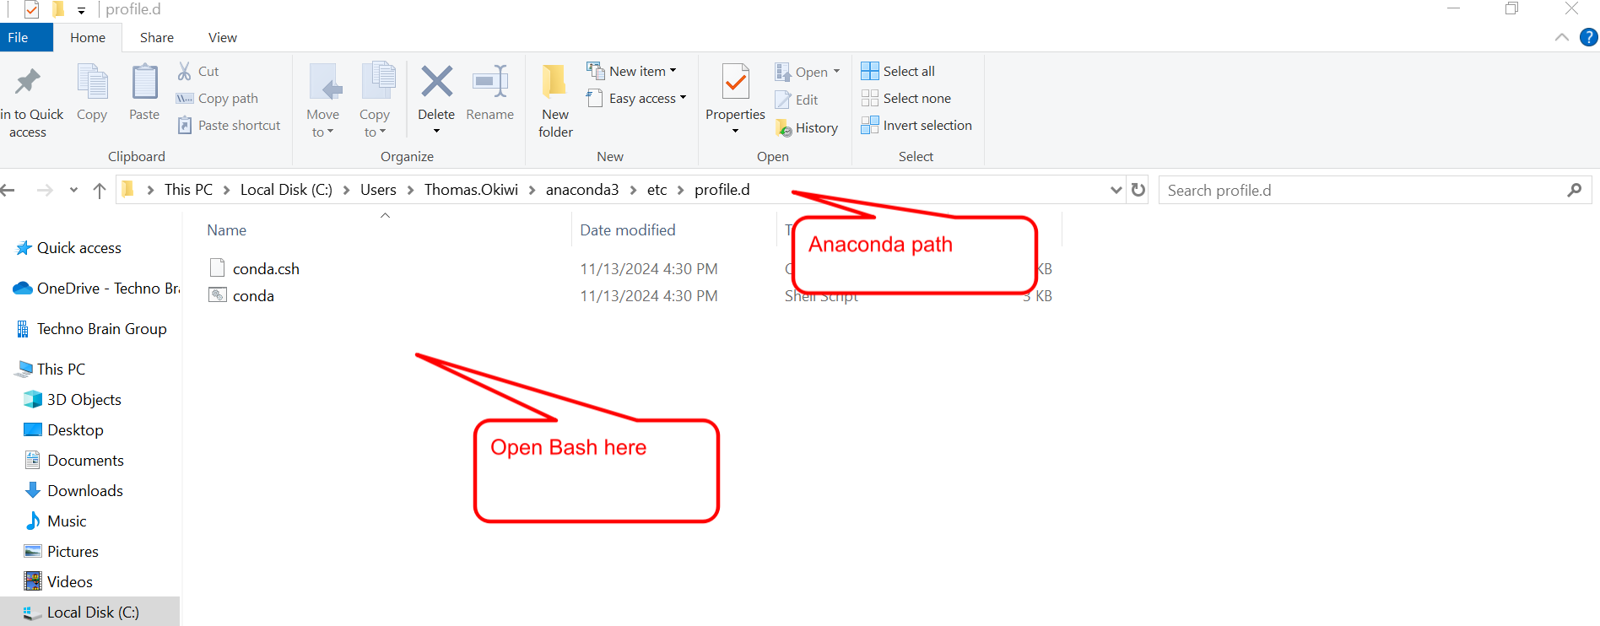

1. Open the bash terminal on the profiled. File path

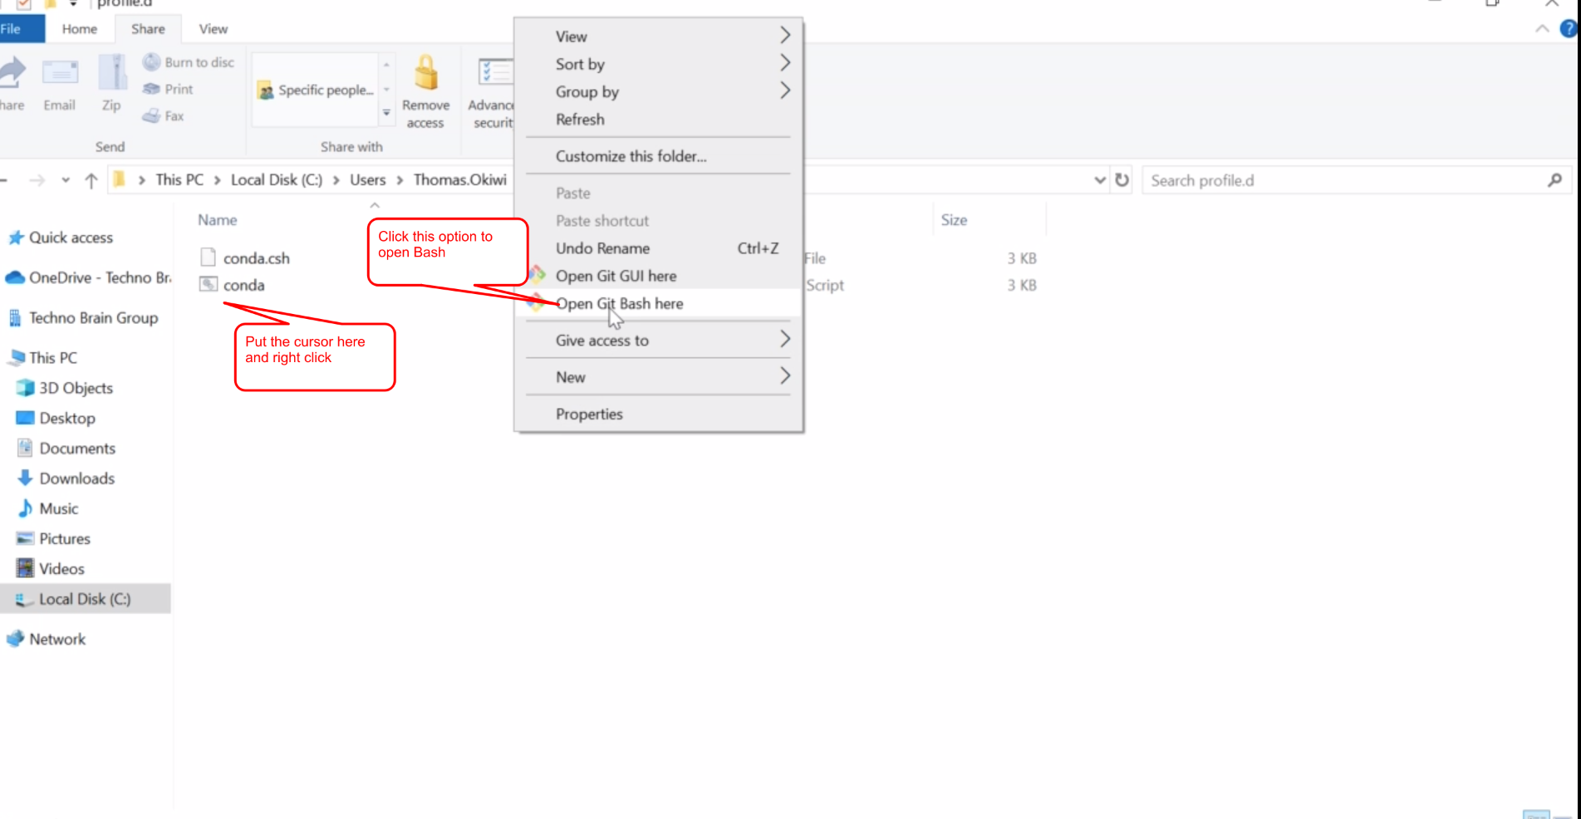

The bash terminal will open as shown

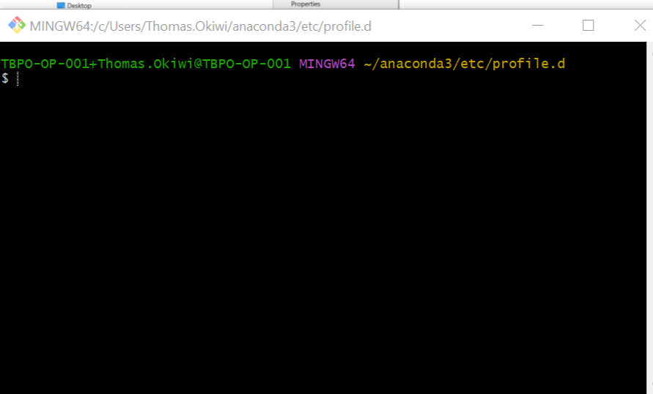

1. Check for which space in the fill path.

Go to directory, type “pwd”

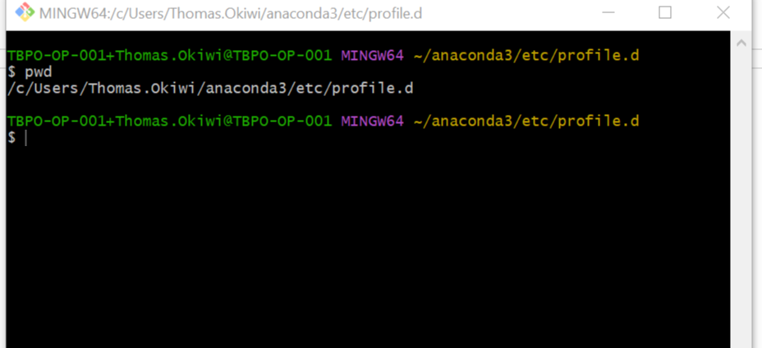

1. Commands

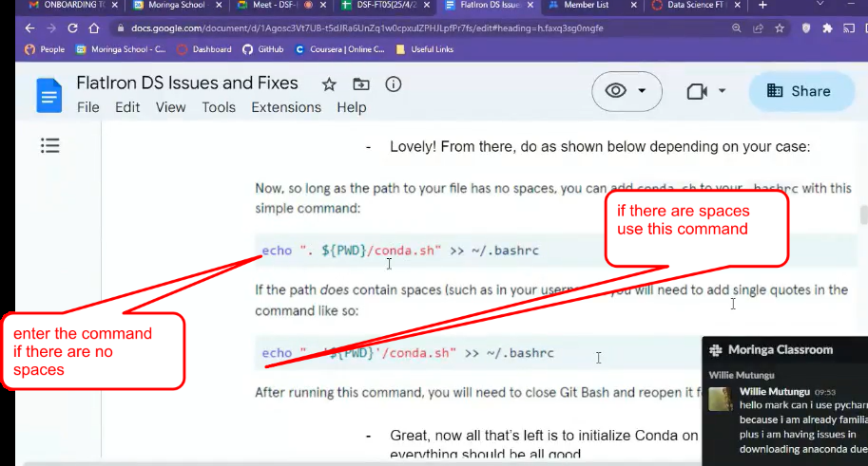

In this case the was no spaces on the path

Type in the first command then execute “ there should be no output”

1. Close the terminal for the changes to take place.
2. Open the bash again
3. Initialize the conda (conda init bash)

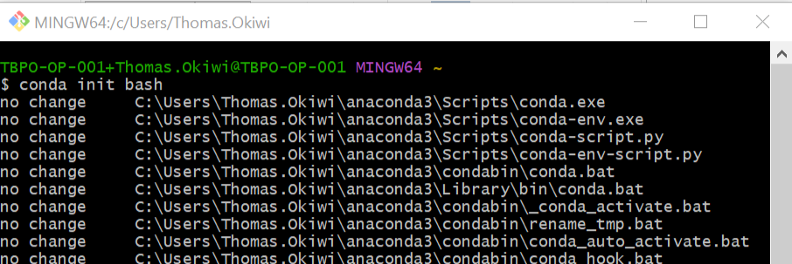

1. Close the terminal and reopen again

It should open with “base”

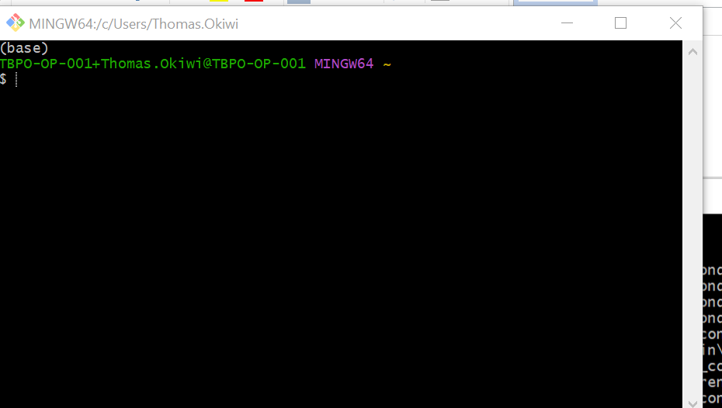

1. Creating the environment

Type the command to create new enviroment

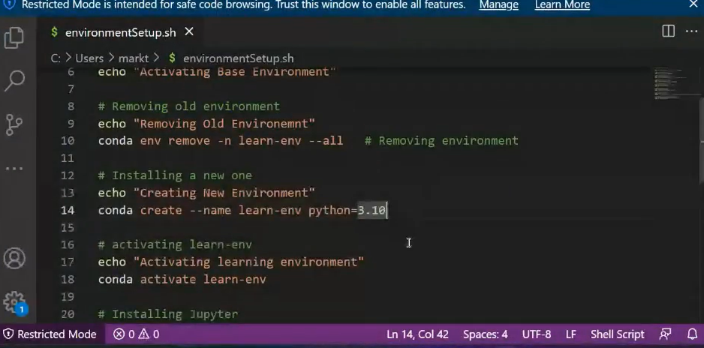

This will be the out come

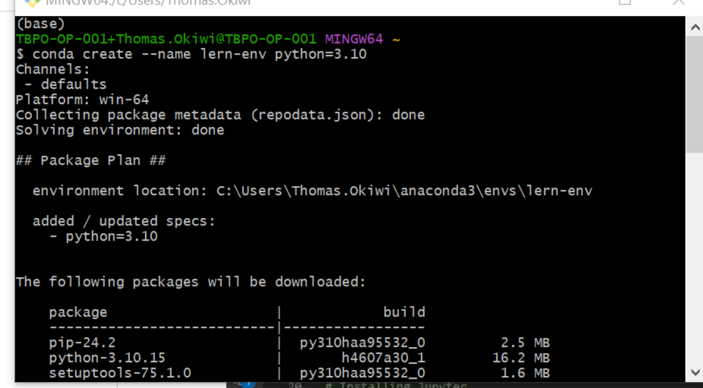

Type yes to continue when prompted

conda activate learn-env

Once all libraries are loaded , activate the enviroment with the following command.

1. conda install -c conda-forge notebook
2. python -m ipykernel install --user --name learn-env --display-name "Python (learn-env)"
3. install jupyter notebook

Execute the following commands

conda install ipykernel

python -m ipykernel install --user --name learn-env --display-name "Python (learn-env)"

1. install the matplotlib

to make automatically launce env ?

execute the command below.

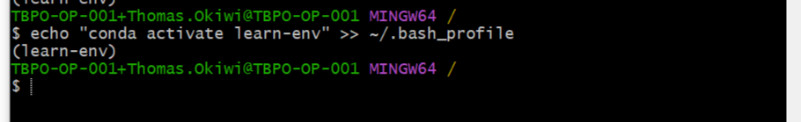

1. Open a VS code

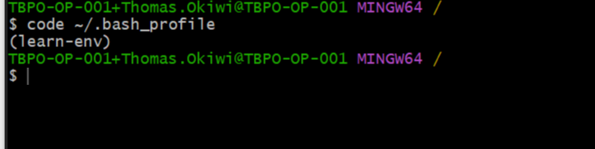

VS code will open as below

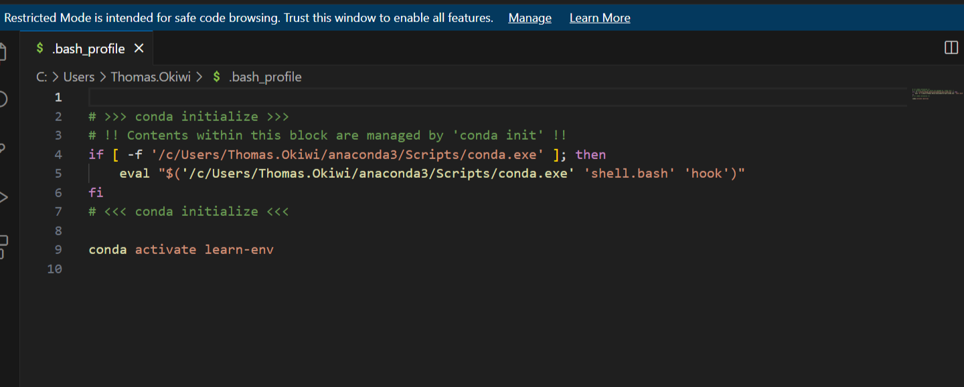

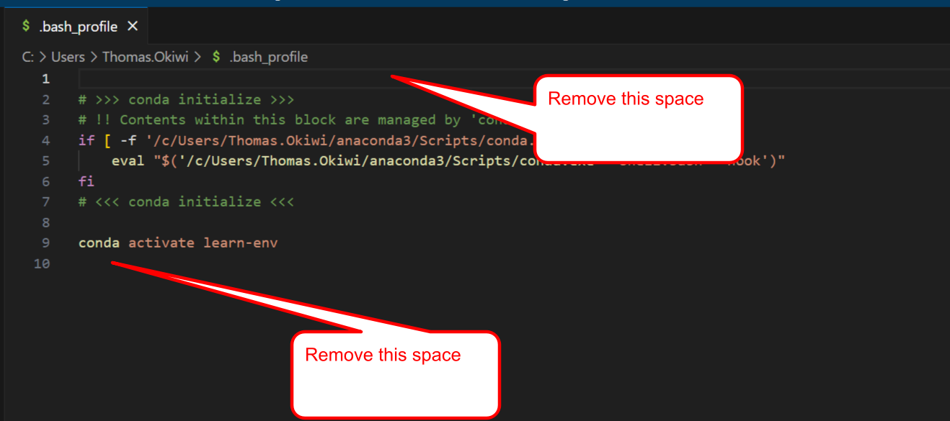

This are the only lines that should remain

